https://github.com/MrRogueKnight/Dev3Pack-Lisk-Solidity-Bootcamp-2025/tree/rogue/homework/Week%202%20Lecture%201%20-%20Smart%20Contract

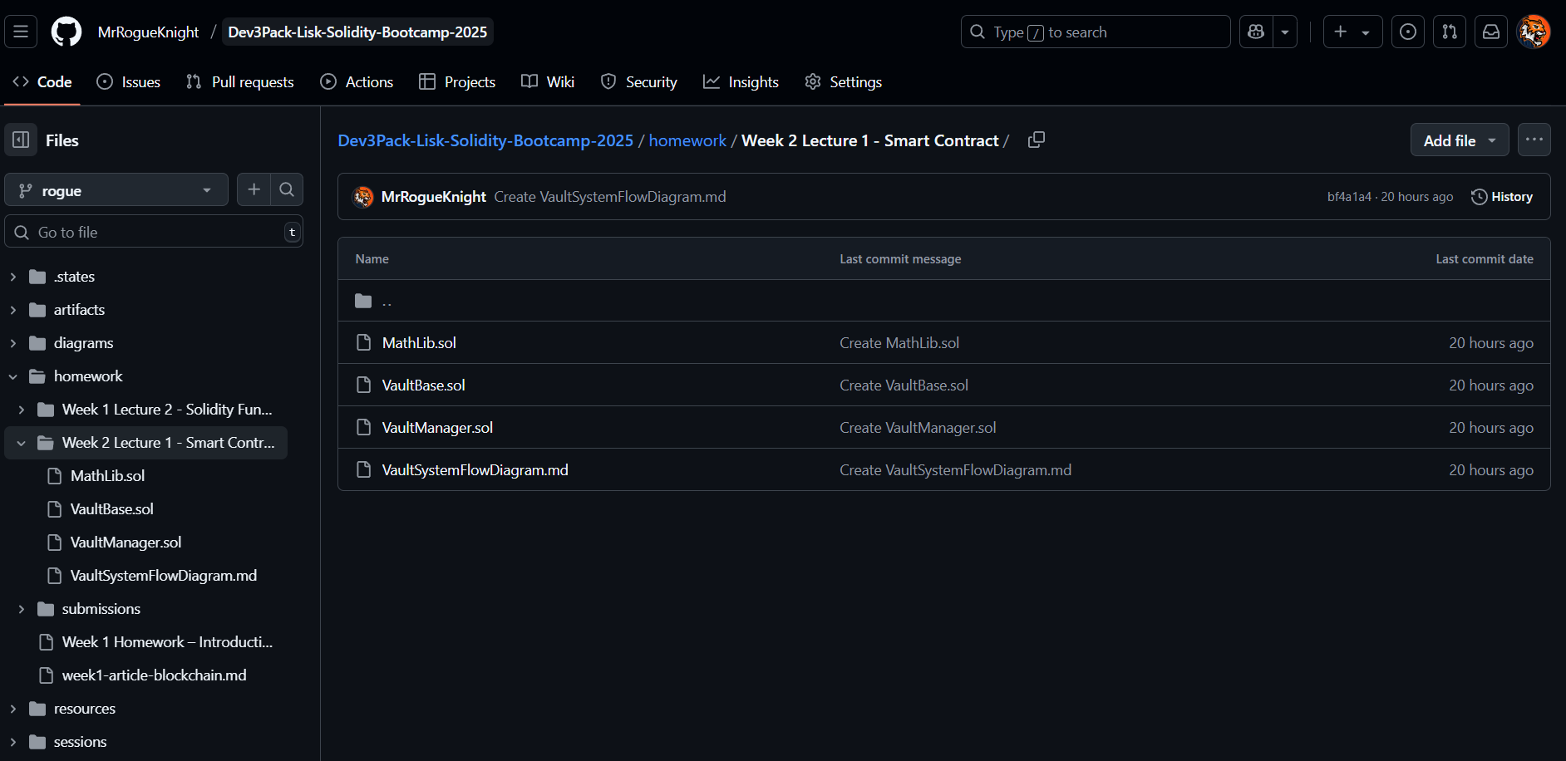

I have successfully implemented a simple Vault system in Solidity that allows users to deposit and withdraw Ether while adhering to the specified requirements. The solution includes:

Library Usage – A math library for secure arithmetic operations.

Event Emission – Logs deposit and withdrawal transactions.

Security Checks – Uses require() to prevent invalid deposits (e.g., zero ETH) and over-withdrawing.

Inheritance Structure – A base contract (VaultBase) for shared logic and a derived contract (VaultManager) implementing deposit/withdrawal functions.

